People, Pronunciation and Play with Luke Meddings
ELTAS Event Review by Michelle Hunter and Jennie Wright
"People, Pronunciation and Play with Luke Meddings" 23rd January 2016, held at ISM Hochschule, Stuttgart
Luke joined us in Stuttgart from London, via Paris and brought with him a breath of fresh air and fresh thinking. Co-author of Teaching Unplugged with Scott Thornbury, Luke demonstrated how Dogme works – with minimal teaching materials and a lot of audience participation. His relaxed and easy-going style soon had us all engaged and prepared to play along with him. His excellent mimicry had us enthralled and entertained as he taught us how to talk like the Queen!
Here are some activities from the session:
Dictation activity: Luke had recorded the train announcement on his way to the workshop with his phone and had us try out a dictation exercise with the recording. The most interesting thing about this was that it was so simple but a task where learners can focus on pronunciation, sentence formation and also elements of register.
Playing a role: Stepping out of our comfort zone, Luke made us speak sentences in different ways to help us pay attention to how our voice changes to play different roles. We were asked to shout, whisper and add emotion to our statements. Although embarrassing, we soon got over it and focused on the changes to our voice. We also tried to speak like politicians making a promise and Luke had the great idea to encourage an accent playday with our learners.
Finding the ‘key’ to a new accent: Luke taught us how to impersonate the Queen! By closing our jaws and vocalising from the back of our mouths, Luke had us all talking like the Queen in a couple of minutes. Very impressive.

Some useful resources were also mentioned. Blog post talking about accents and singing: http://www.hakansblog.com/search/label/singing Robin Walker (pronunciation expert) on teaching pronunciation: https://oupeltglobalblog.com/2012/01/05/pronuncia-tion-matters-part-1/
Many thanks also for the lovely soup during the break!
Lifelong learning enthusiast, voracious reader and committed advocate of teacher development. Michele has lived in southern Germany for 20 years, worked as a freelance English teacher for 16 years in companies and universities. She has spoken at teacher conferences, written for teaching journals and writes a blog: The Teachers Coach.

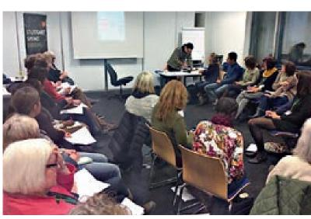
ELTAS Members Working Hard
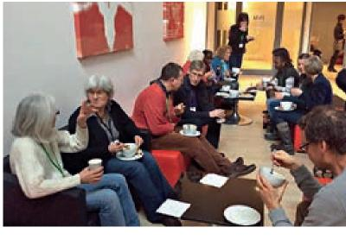
Soup Time!
