EVENT REVIEW
Teaching Listening and Speaking Skills with Cornelia Kreis-Meyer ELTAS Event Review by Kirsten Bergen

"Teaching Listening and Speaking Skills with Cornelia
Kreis-Meyer" – sponsored by Cornelson - 4th June 2016, held at Cornelson, Stuttgart
Cornelia Kreis-Meyer, advisor for ISD GmbH, consultant for the Cornelson Simply Business coursebook series, former long-time ELTAS and BESIG board member, and 20 year ELT trainer led the workshop which was held at Cornelson, Stuttgart.
The workshop started by introducing the theory behind listening skills, both for native speakers and for learners of a foreign language. She launched us into the subject by presenting research findings into language acquisition which show that babies as young as six months already imitate the melody and intonation of a language when responding to parents or other speakers.
She then led us through David Nunan’s six stages of listening (from Designing Tasks for the Communicative Classroom 1989, CUP): Hearing (this is, as any parent and many teachers know, very different from listening); Attending (paying attention, screening stimuli to focus); Understanding (making sense of the sounds heard and transforming them into words recognized or known); Remembering (what is remembered may be quite different from what was originally heard or seen); Evaluating (listening effectively – to the end, without interrupting – allows for better evaluating); and finally Responding (verbal or non-verbal feedback).
From there the workshop moved on to look at why speaking a foreign language can be so difficult. Reasons presented included the fact that, when listening, the speaker is faced with a number of challenges, including word stress, rhythm, intonation, language use, accent, idiomatic expressions and vocabulary, and has to react and respond appropriately in real time (with little or no time for reflection). Many speakers, especially at earlier stages of language acquisition, are unable to cope with all of these simultaneous demands.
To round off the listening and speaking theory part, participants were presented with two classroom activities which reveal a lot about how students have listened and remembered and can also be used to recycle language learned. The first activity was called Top 5 Words. Students are invited to give their favourite words from the previous meeting and to explain why they chose the words. The second activity used a Johari Window which looks at scenarios involving expected encounters with known content, unexpected encounters with known content, expected encounters with unknown content, and unexpected encounters with unknown content. This exercise can provide a framework for preparing for and giving feedback on situations such as business trips or trade fairs.
The workshop ended with a presentation of the Simply Business coursebook series with feedback from teachers who already use the books.
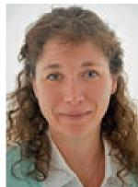
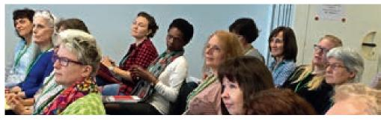
Kirsten Bergen, Canadian born and British educated translator, interpreter and CELTA certified teacher has lived in Germany for 17 years and been a language trainer for 13 years.

She is currently employed by the Anglo-German Institute in Stuttgart.

11 | ELTAS NEWS

