EVENT REVIEW EVENT REVIEW

Use of Authentic Video with TED Talks with Tim Phillips ELTAS Event Review by Philippa Walker

"Use of Authentic Video with TED Talks" with Tim Phillips –
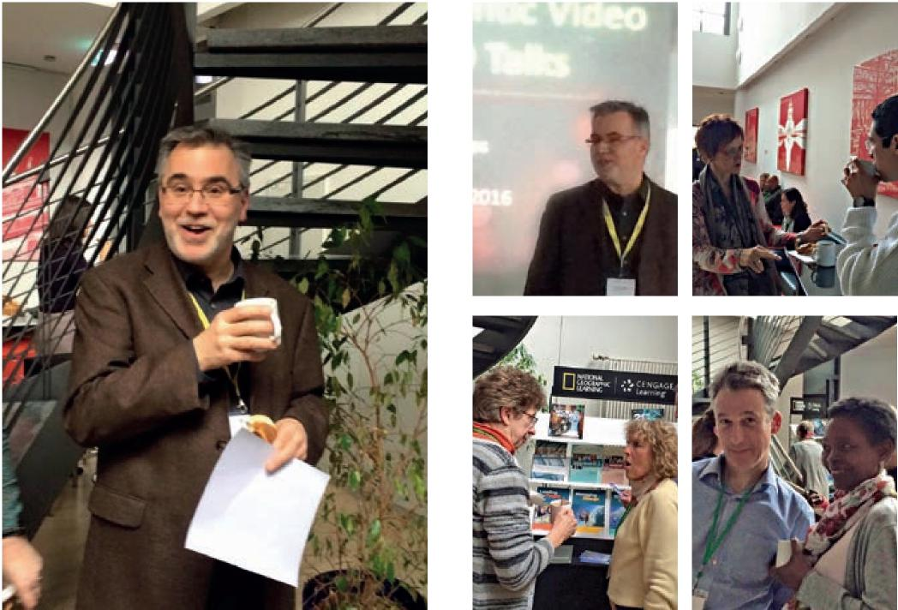
Tim having a little break!
sponsored by National Geographic Learning
12th March 2016, held at ISM Hochschule, Stuttgart
~~
e convened at the International School of Management to join Tim Phillips’ workshop about using TED videos in the classroom. Tim now works for National Geographic Learning, part of Cengage Learning, which acquired the rights to create ELT materials based on the well-known TED Talks.
Tim first gave us a brief overview about TED in general in the form of a quick quiz – I never knew that the most viewed video of all time was Ken Robinson’s Do Schools Killed Creativity?, or that TED videos have been viewed over 1 billion times (if you have never heard of TED Talks, it is a non-profit organisation spreading ideas in the form of short talks by amazing people – www.ted.com).
Then to the nitty-gritty – classroom activities. Tim selected the following range of talks which can be used to great effect in the ELT classroom:
- How to start a movement by Derek Sivers
- The good news on poverty by Bono
- The linguistic genius of babies by Patricia Kuhl
- A life lesson from a volunteer firefighter by Mark Bezos
- How to tie your shoes by Terry Moore
PRE-VIEWING ACTIVITIES:
Tim suggested such things as pre-teaching key vocabulary, creating interest by finding out key facts about the speaker or finding pictures or images that raise interest in the topic. Tim chose to create interest in the pre-viewing stage by putting us into small groups to answer one question: What makes a good leader? After discussing this, we were ready to watch How to start
a movement by Derek Sivers, a 3-minute video about how a leader is made by the first follower.
WHILE-WATCHING ACTIVITIES:
Tim suggested two viewings of the video: the first just to watch and enjoy and a ‘while watching’ task for the second viewing. In the workshop we did exactly this with a talk by Bono The good news on poverty. The task was to fill in a table provided by Tim with key words about three problems and their solutions from the video.
OTHER IDEAS FOR ‘WHILE WATCHING’ ACTIVITIES:
- What information do you learn about the speaker and his/her background?
- Summarise the main idea of the talk in one sentence. What supporting details or examples does the speaker use to support his/her idea?
- How does the speaker engage the audience? (Images, charts, humour, actions, etc.)
- What is your opinion of the talk?
- What language in the video was new to you?
POST-WATCHING ACTIVITIES:
- Discussion around the topic – critical thinking, e.g. what are the goals and aims of the speaker in making their presentation?
- Summary writing
- Use comments from the website (which can be found under each video) read them and add your own comment
- Brainstorm questions for the speaker
- ‘Interview’ the speaker
Examples of all the tasks and rationales can be found on Tim’s slides which can be accessed via the ELTAS website.
I have been using TED Talks for several years now, and I have created my own material around a few favourites. I was on the lookout for some ideas to make frame activities, i.e. worksheets that could be adapted to several videos, and certainly some of Tim’s activities can be adapted without too much preparation for several different TED Talks, surely a great advantage for the business English teacher.
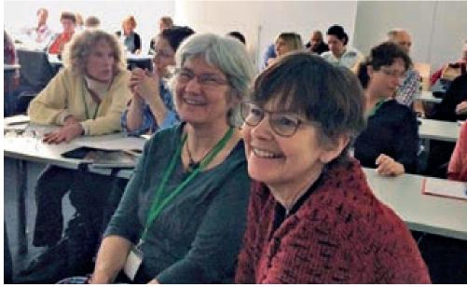
Pippa Walker and Chris Stanzer
Pippa Walker:
I have been training business English around the Stuttgart area since 2000, and I have been a member of ELTAS since around 2004. I love Germany but am about to relocate back to Bristol, UK! What wil I miss? The German relaxed lifestyle (like quiet Sundays), the Schönbuch Forest, and my students, coleagues and friends. I invite you to keep in touch with me via Linkedin.

ELTAS NEWS | 10 11 | ELTAS NEWS

